Year 11 Transition Booklet –

BTEC Level 3 Computing 2023-24
BTEC National Computing: Transition Guide
Examination Board: Pearson
BTEC Level 3 National Extended Diploma in Computing is equivalent to 3 A Levels and comprises of 13 units (4 external an 7 internal).
BTEC Level 3 National Extended Diploma in Computing
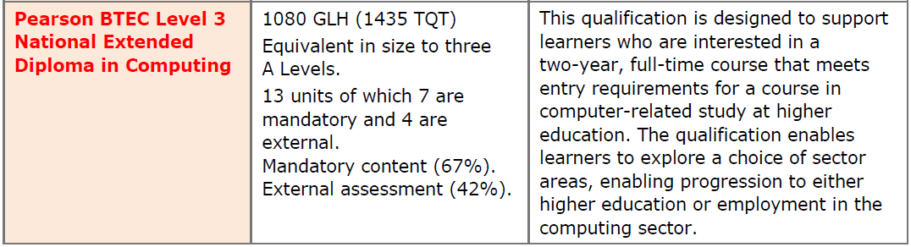

Resources you will be using in this course:
Specification | Textbook | Revision Books
 | 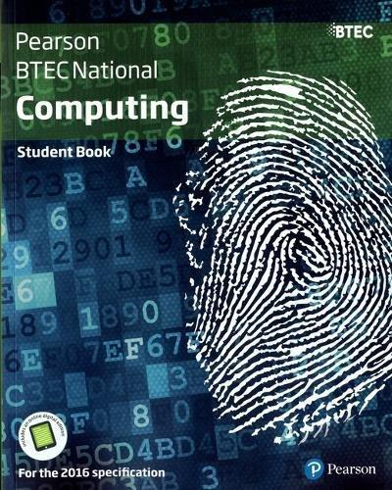 | 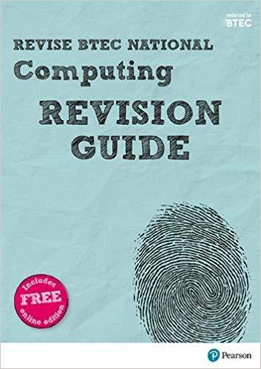

Year 12:
Units Covered | Assessment
Unit 1 Principles of Computer Science | External
Unit 2- Fundamentals of Computer Systems | External
Unit 3 - Planning and Management of Comptuer Systems | External
Unit 8 -Business Application of Socail Media | Internal
Unit 10 -Human-computer Interaction | Internal
Unit 15 - Website Development | Internal
Unit 18 - Relational Database Development | Internal
Unit 14 - Computer Games Development | Internal

Year 13:
Units Covered | Assessment
Unit 4 - Software Design and Development Project | External
Unit 7 - IT System Security and Encryption | Internal
Unit 9 - The Impact of Computing | Internal
Unit 22 - Systems Analysis and Design | Internal
Unit 19 - Computer Networking | Internal
Unit 14 - Computer Games Development | Internal

Transition Activities: : Week 1 - 24/07/23
The following Tasks will need to be attempted during this week. Your knowledge in these topics will be assessed in a classroom test.
Task 1: Programming
Programming Task Activity 1:

Visit www.w3schools.com/python and work
through Python Exercises.

You must cover the following topics:
Python Syntax
Python Variables
Python Numbers
Python Strings
Python Operators
Python Lists
Python Sets
Python Dictionaries
Python If…Else
Python While Loops

Task 2: Programming Exercises:

Register with www.codecademy.com and work through “Programming with Python” tutorial.

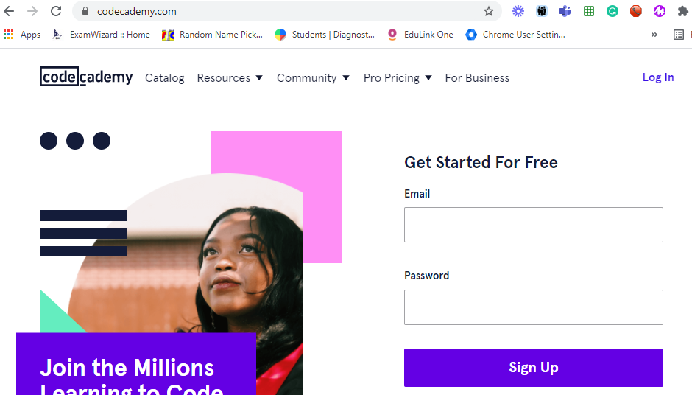

Task 3 - Week 1 Assessment
(To be completed after you have completed Task 1 and 2 above)
https://docs.google.com/forms/d/e/1FAIpQLScWmKdZrYr1Aw7fWFFqIUNit3bOz0TUEPY3D17L5xG3DQgTnA/viewform?usp=sf_link

Transition Activity: : Week 2 – 31/07/23 (Social Media)
Task 1 – Social Media
Students should familiarise themselves with social media. You should examine how businesses use Facebook and Twitter and become familiar with how they work.
Young people in the UK regard Facebook as something that old people use. However, by numbers, it is still by far the most widely used social platform. Watch this short video on ways businesses can use Facebook other than just “spamming” page followers with ads.
We will not necessarily be focusing on how social influencers on other platforms (such as Instagram or TikTok) work on behalf of businesses. We will not just be focusing on the well-known aspects like advertising or sponsored posts.
Find examples for, and explain:
- Other than advertising or sponsored posts, how do businesses present themselves on Facebook and Twitter?
- How do businesses use social media to communicate directly with customers to resolve issues and provide customer service? What examples can you find?
- How do businesses use social media to create brand awareness?
- How have businesses used social media in a way that was not expected, or where risks and issues (e.g., hacking, inappropriate conduct) have not been managed?

Task 2 - Week 2 Assessment
(To be completed after you have completed Task 1 above)
https://docs.google.com/forms/d/e/1FAIpQLSc5-yGGyKAHrshi7hJSDPOXwswA5aAdaUgkIrMPMrbuowI2pQ/viewform?usp=sf_link

Transition Activity: : Week 3 – 07/08/23
Task 1 - Systems to Manage Information (Databases)

One of the hardest units in this course is creating a relational database. We will be using Microsoft Access, however, free software like OpenOffice Base is fine when you’re just starting out.
To prepare yourself, watch this video on the high-level concepts of relational databases.
The key points you should be able to discuss are:
- What is a relational database?
- Why do you think duplicate data a problem in a database?
- What are “one to many” and “many to one” relationships?

Task 2 - Week 3 Assessment
(To be completed after you have completed Task 1 above)
https://docs.google.com/forms/d/e/1FAIpQLScqgcz66DSZd9s5fMO0p94n5ItbjTINWIg3GpJOqEoLVnNCfg/viewform?usp=sf_link

