SUBJECT SPECIFICATION FOR A LEVEL MATHEMATICS

Students study a variety of topics across the two years of A Level Mathematics.
The Pearson Edexcel Level 3 Advanced GCE in Mathematics consists of three externally examined papers.
Students must complete all assessment in May/June in any single year.

Paper 1: Pure Mathematics 1
Written examination: 2 hours (calculator)
33.33% of the qualification
100 marks

Content:
Proof; algebra and functions; coordinate geometry in the (x, y) plane; sequences and series; trigonometry; exponentials and logarithms; differentiation; integration and vectors.

Paper 2: Pure Mathematics 2
Written examination: 2 hours (calculator)
33.33% of the qualification
100 marks

Content:
Proof; algebra and functions; coordinate geometry in the (x, y) plane; sequences and series; trigonometry; differentiation; integration and numerical methods.

Paper 3: Statistics and Mechanics
Written examination: 2 hours (calculator)
33.33% of the qualification
100 marks
The paper comprises of two sections: section A (statistics) and section B (mechanics).
Content:
Section A - Statistical sampling; data presentation and interpretation; probability; statistical distributions and statistical hypothesis testing.
Section B – Quantities and units in mechanics, kinematics, forces and newton’s laws and moments

SUBJECT SPECIFICATION FOR A LEVEL FURTHER MATHEMATICS

A Level Further Mathematics consists of 4 externally examined papers. Students must take Paper 1 and Paper 2, the two mandatory Core Pure papers, and two optional papers. Students are permitted to take more than the two optional papers if they want to extend their course of study.
Paper 1: Core Pure Mathematics 1
Paper 2: Core Pure Mathematics 2
Each paper is: 1 hour and 30 minutes written examination 25% of the qualification 75 marks
Content overview: Proof, Complex numbers, Matrices, Further algebra and functions, further calculus, further vectors, Polar coordinates, Hyperbolic functions, Differential equations 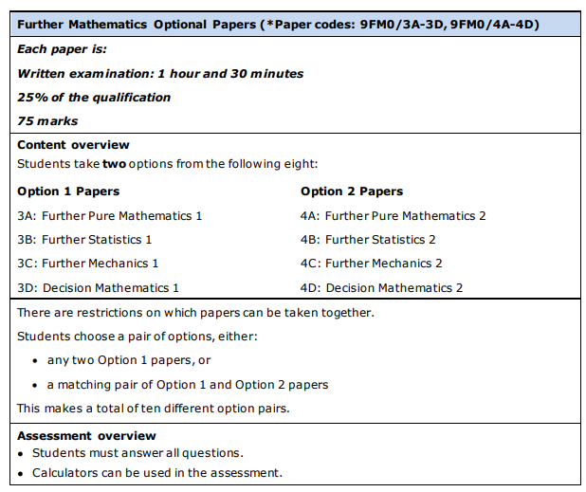
Entry Requirements
Mathematics: GCSE grade 7 and above. Further Mathematics: GCSE grade 8/9.

TASK

Week 1 - 24/07/23 Trigonometry

Hello everyone! Over the next few weeks you will get an insight on what A Level Maths really is. Please watch the videos, go over the further examples and the answer all the questions.
Good luck!

Watch this….
https://corbettmaths.com/2019/12/31/solving-trig-equations-videos/

Further examples:
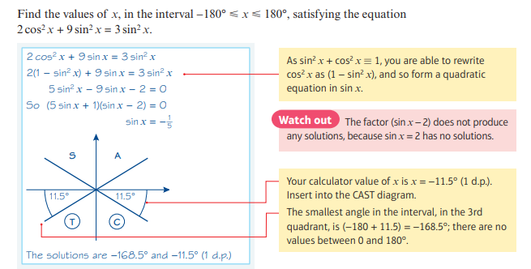
Example 1:

Example 2:
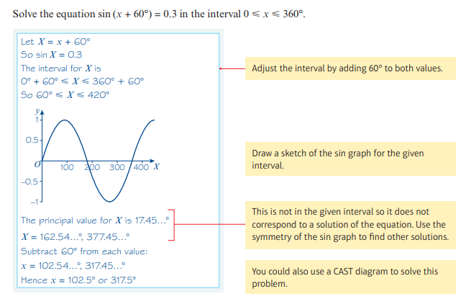

Questions:
Answer all questions from this booklet:
https://www.mathsgenie.co.uk/resources/as-pure-solving-trig-equations.pdf

Week 1 Assessment. Complete this only after you have answered questions from the section above.
https://forms.gle/ysCGjAZTWzBHhQ6Z8

Week 2 – 31/07/23 Coordinate Geometry

Watch this video:
https://corbettmaths.com/2019/12/31/equation-of-a-tangent-to-a-circle-video/

Further Examples:
Example 1:
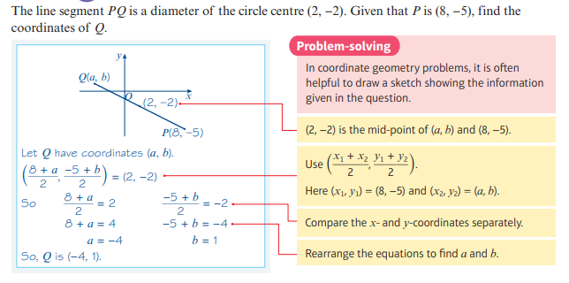

Example 2:
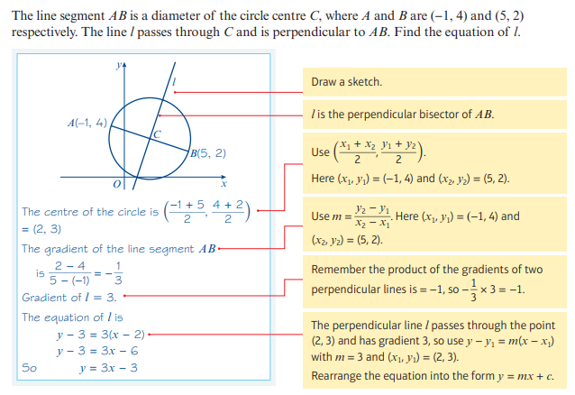

Questions:
Answer all questions from this booklet:
https://www.mathsgenie.co.uk/resources/as-pure-equation-of-a-circle.pdf

Week 2 Assessment. Complete this only after you have answered questions from the section above.
https://forms.gle/LWigVJ8bbYNq6YCn8

Week 3- 7/7/23 Simplifying Algebraic Fractions
Watch this video:
https://corbettmaths.com/2019/12/30/algebraic-fractions-videos/

Further Examples:
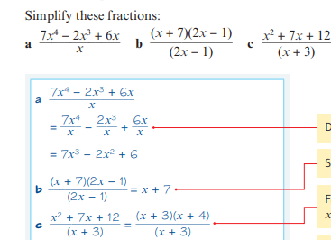

Questions:
Answer all questions from this booklet:
https://www.mathsgenie.co.uk/resources/as-pure-algebraic-expressions.pdf

Week 2 Assessment. Complete this only after you have answered questions from the section above.
https://forms.gle/7RYEvUYJiAbJW6tC9

