Year 11 Transition Booklet –

A Level Computer Science 2023-24
"Everyone should learn how to code, it teaches you how to think!”
Steve Jobs

Computer Science: Transition Guide

A Level Computer Science
Examination Board: OCR
Within the course there are 3 components:

Resources you will be using in this course:
Specification | Textbook | Lesson Materials
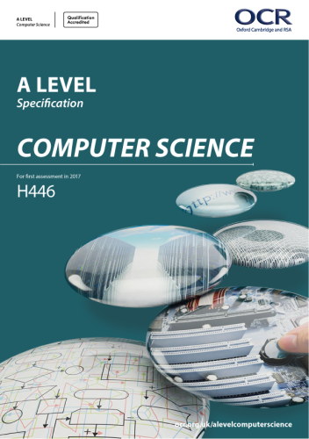 | 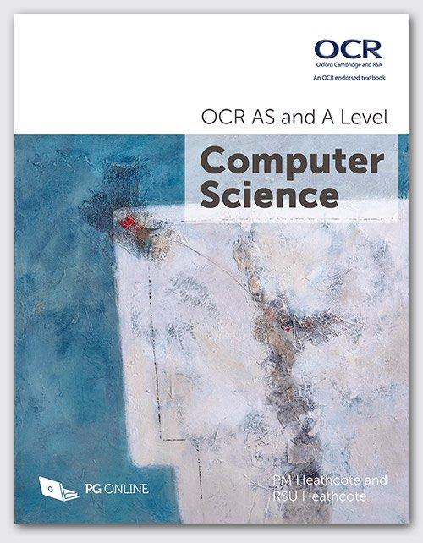 | 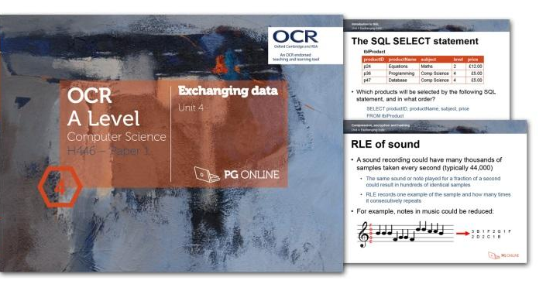

Year 12:
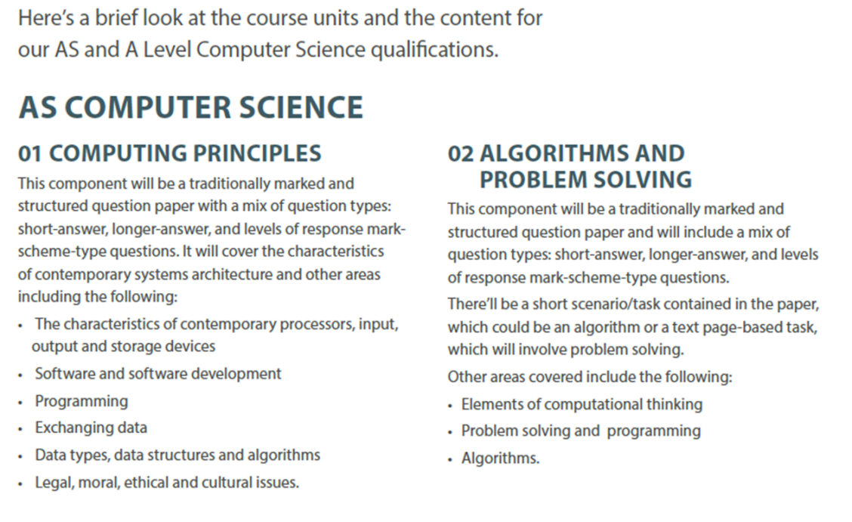
Year 13:

Transition Activity: Week 1 - 24/07/23 (Python Programming)
The following Tasks will need to be attempted before during this week. Your knowledge in these topics will be assessed in a classroom test.
Task 1: Programming
Programming Task 1:
Visit www.w3schools.com/python and work
through Python Exercises.

You must cover the following topics:
Python Syntax
Python Variables
Python Numbers
Pyton Strings
Python Operators
Python Lists
Python Sets
Python Dictionaries
Python If…Else
Python While Loops

Task 2: Programming exercises:

Register with www.codecademy.com and work through “Programming with Python” tutorial.

Task 3 - Week 1 Assessment
(To be completed after you have completed Task 1 and 2 above)
https://docs.google.com/forms/d/e/1FAIpQLSf67ldnR0TcB3WErju3Z5AaleGkDEHSQwjM2c19VbHJf-Wnbg/viewform?usp=sf_link

Transition Activity: : Week 2 – 31/07/23 (Systems Architecture)
Task 1 : Understanding Computer Architecture
Visit the Teach-ICT.com website and read through topics on “1.1 Architecture”, and make essential notes and mindmap from the link below. You will need the following username and password for the

Teach-ICT website:
Link to Teach-ICT.com
https://teach-ict.com/2016/A_Level_Computing/OCR_H446/OCR_H446_home.html

Login details for Teach-ICT.com
Username: e10rh
Password: python8

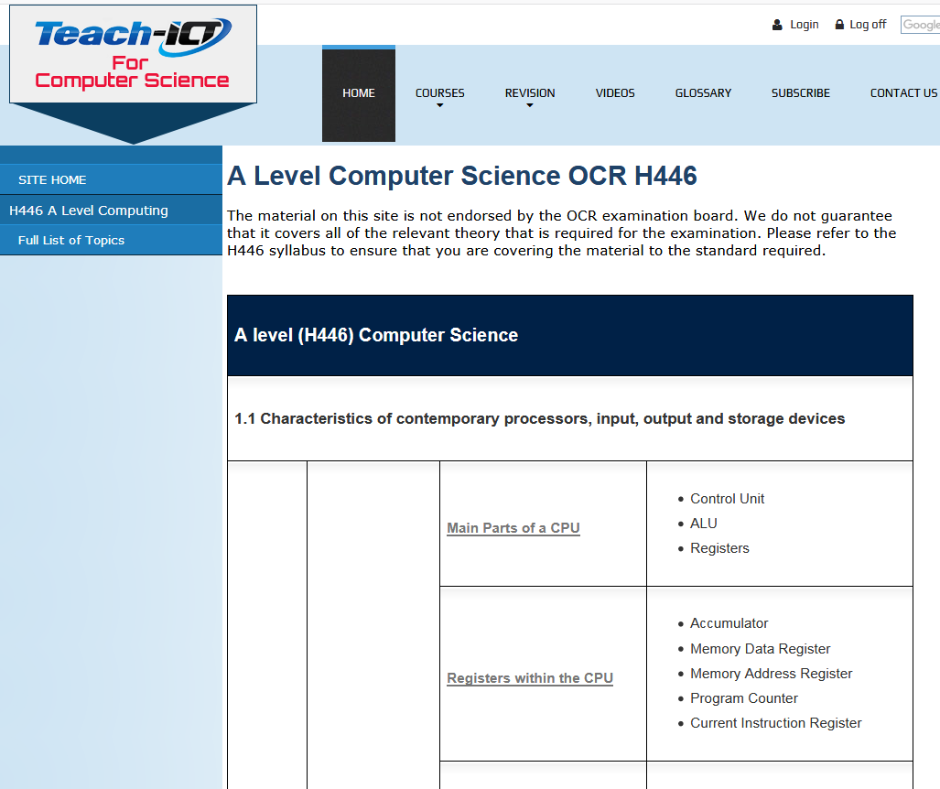

Topics to cover:
Main Parts of a CPU, Registers within the CPU, Fetch-Decode-Execute Cycle, CPU performance factors, System performance factors, Von Neumann and Harvard

Task 2 - Week 2 Assessment
(To be completed after you have completed Task 1 above)
https://docs.google.com/forms/d/e/1FAIpQLSe1ycC8Jle0l4D-wfsLvnHKOIz9Ucd3K0Y2pw9ZCyRB3K7XAQ/viewform?usp=sf_link

Transition Activity: : Week 3 – 07/08/23
Data Types, Data Structures and Algorithms
Use the teach-ict.com website to develop your knowledge and attempt these task.
Task 1 Converting between denary, binary and hex
No | Denary | Binary | Hex | Add 00011110 to the Binary value in column 3
1 | 1
2 | 5
3 | 10
4 | 22
5 | 40
6 | 77
7 | 91
8 | 121
9 | 144
10 | 168
11 | 170
12 | 200
13 | 211

Task 2
Create a program that analyses a passage of text from a file and then counts:
● How many words
● The average length of a word
● How many times each word occurs
● How many words start with each letter of the alphabet?
● The aim of this exercise is to test your ability to develop algorithms

Task 3 Binary Truth Tables
Write the truth tables for the expressions
NOT (A AND B)

and ((NOT A) OR (NOT B))
2. What do you notice about these tables?

Task 4 - Week 3 Assessment
(To be completed after you have completed Task 1 above)
https://docs.google.com/forms/d/e/1FAIpQLScEsAmXJVGU02sYLoLSmZWZGZkBD1UP0mNUQ7tzAK7aeGUcrw/viewform?usp=sf_link​

