Step Up to Spanish A Level

at Stepney All Saints

Why Spanish?
Congratulations on selecting Spanish A Level. You have opened the door of opportunity! Studying Spanish will enrich your life, giving you opportunities to travel abroad and to learn about different cultures and different ways of life. Studying a language will also enhance your life chances, as universities and employers tend to prefer candidates who can speak more than one language.

Did you know that linguists are better communicators and writers and have a better understanding of their own language too? Students who study languages do better in tests and learning a language will improve the functionality of your brain and improve your memory skills.

Spanish is currently the 4th most spoken language worldwide. Geographically, many countries have Spanish as a dominant language from Spain to Mexico and beyond. Knowing Spanish means you could communicate with a third of a billion speakers worldwide!

Studying A Level Spanish will enable you to learn the Spanish language and you will also gain an in-depth insight into the cultural, social, political, and artistic aspects of the Spanish speaking country/countries you will study.

A Level Spanish – Introduction to the course
At A Level, we follow the AQA syllabus.
What will I learn?
During this course you will develop your linguistic skills alongside your understanding of the culture and society of the countries where Spanish is spoken.
You will study:
- technological and social change, looking at the multicultural nature of Hispanic society.
- highlights of Hispanic artistic culture, Spanish regional identity and the cultural heritage of past civilisations.
- aspects of the diverse political landscape of the Hispanic world.
- the influence of the past on present-day Hispanic communities.
Throughout your studies, you learn the language in the context of Hispanic countries and issues and influences which have shaped them. You will study texts and film and will have the opportunity to carry out independent research on an area of your choice.
Course structure
The AQA A level in Spanish comprises three units.
Paper 1: Listening, reading and writing
Paper 2: Writing (Essay on a novel + a film)
Paper 3: Speaking (involving discussion on a topic of your choice)
General Topic Areas for A level Spanish
The topics you will cover are as follows:
Year 1
Aspects of Hispanic society  • Modern and traditional values  • Cyberspace  • Equal rightsr 2 | Artistic culture in the Hispanic world  • Modern day idols  • Spanish regional identity  • Cultural heritage
Year 2
Multiculturalism in Hispanic society  • Immigration  • Racism  • Integration | Aspects of political life in the Hispanic world  • Today's youth, tomorrow's citizens  • Monarchies and dictatorships  • Popular movements

Transition Activities:
How can you prepare for A Level Spanish?
You are to be set three tasks. These are linked to skills you will need at Spanish A Level. We will focus on:
- Analysis of film
- Individual Research Project
- Grammar and comprehension

Task 1 – Analysis of film
Write a film analysis. At A level you study a Spanish language film, but the focus is on analysis and a deep understanding of themes and issues raised. The film for this task is called “A Cambio de Nada” and is by the director Daniel Guzmán staring Miguel Herrán.

Work through the following to complete task 1:

Trailer: Click on play below
Or click on the following link: https://www.youtube.com/watch?time_continue=4&v=V3qXCDkSmrI&feature=emb_logo

Watch:
A CAMBIO DE NADA (Title in English = Nothing in Return) – film by Daniel Guzmán (Age rating 13. This film is currently available on Netflix + you can add English subtitles)

A Cambio de Nada – Un resúmen

To write your summary use the following bullet points:
- Introduction (Introducción): Title of the film, director and say who the main characters (personajes) are:
- Darío
- Luismi
- Caralimpia
- Antonia
Example:
A Cambio de Nada, una película dirigida por Daniel Guzmán, trata de las experiencias de Darío, un chico de dieciséis años. Su mejor amigo se llama Luismi y son vecinos. Los padres de Darío están separados: una situación que no es fácil para Darío.

- Characters (Personajes): Find adjectives in Spanish to describe the following characters:
Example:
Cada personaje es diferente. Darío es ……..

- Favourite character (Personaje preferido): Describe your favourite character and explain why:
Example:
El personaje que más me gusta es ……. porque …………..
(Edad / Carácter / Problemas / Relación con su familia / sus amigos)

- Themes (Temas): What would you say the film is highlighting as social issues?
Example:
El tema principal de esta película es …..
→ Las juventudes problemáticas (conflictos con la familia, el colegio, la justicia)
→ La familia y la responsabilidad de los padres
→ La amistad
→ La adolescencia
→ Las relaciones entre diferentes generaciones
- Cultural references (Referencias culturales): Films often make references to other aspects of culture e.g. older
works of literature, music, customs, etc. It has been said that in this film Darío is Don Quijote and Luismi is Sancho Panza. Find out who these characters from classical Spanish literature are and say whether you agree.
Example:
En la película, Daniel Guzmán hace varias referencias a la Literatura Clásica Española. El director hace una comparación entre las figuras Don Quijote y Sancho Panza. Estoy de acuerdo con esta observación porque …..

- Conclusion (Conclusión): Say what you thought overall of the film.
Example:
Concluyendo, diría que esta película …….
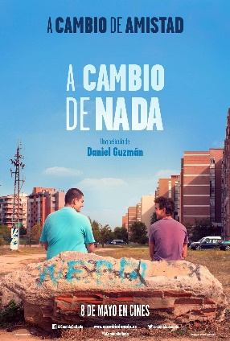

Task 2 - Individual research project (Speaking)

As part of the speaking exam at A level, you talk about a topic of your choice. This must be based on an area of interest linked to the Spanish-speaking world and focuses on developing your independent research skills. It is best to select an area of interest to you. In previous years students have chosen the following:
- Street Art in Madrid by the artist Muelle
- Barcelona Football Club and Catalan Identity
- Political change in Cuba
- Feminism in Spain
- Muslim identity in modern Spain
- Student protests in Chile
These were all chosen by students based on their own areas of interest. The idea is that you should be an expert on your chosen topic.

Task 2 is to prepare a presentation on an area of interest to you that is linked to the Spanish-speaking world. This would be a spoken presentation, however for this task it will be written.
- Think of something that interests you e.g. sport, music, identity politics, etc.
Example: Music
- Narrow this down to an example of this in a Spanish-speaking country. You will need to research this online.
Example: Reguetón
- Find out about the origins of your topic and compare with today.
Example: The origins of this music; how it has grown in popularity; the growth of the Latino community, etc.
- Prepare bullet points in Spanish. You can use phrases from your research. Make sure you understand what they all mean.
Example:
- El reguetón ​ es un género musical bailable que se deriva del reggae y del dancehall, así como elementos principalmente del hip hop, y la música hispana.
- Es un género musical muy popular hasta hoy día, que tuvo su apogeo máximo en los años 2000 y 2010.
- Se influenció del reggae en español de Panamá y se desarrolló en Puerto Rico en 1990; surgió a raíz de la popularidad del reggae jamaicano, junto con el hip hop estadounidense durante los inicios de esa época.
- El reguetón entró en los Estados Unidos en los años 1990 y 2000 y se ha convertido en un modo de expresión para muchos jóvenes hispanos.
A lot of the A level course is about expressing opinions, defending your opinions, and justifying your point of view. Start to think about your opinions on your topic area. You may change your opinions as you start learning about the issue.

Task 3 – Grammar and comprehension

When covering all of the General Topic Areas for A level Spanish we will also look in depth at grammar skills and how the Spanish language is held together by patterns and rules.
As an example of this work, we will look at recent events across the world and how Spain has reacted as a country.

Task 3 is to work through texts on the Coronavirus and certain aspects of grammar.

Click on the video below (if you are connected to the internet it will play directly) or click on the link - https://www.youtube.com/watch?time_continue=9&v=gqujGvAfsfM&feature=emb_logo
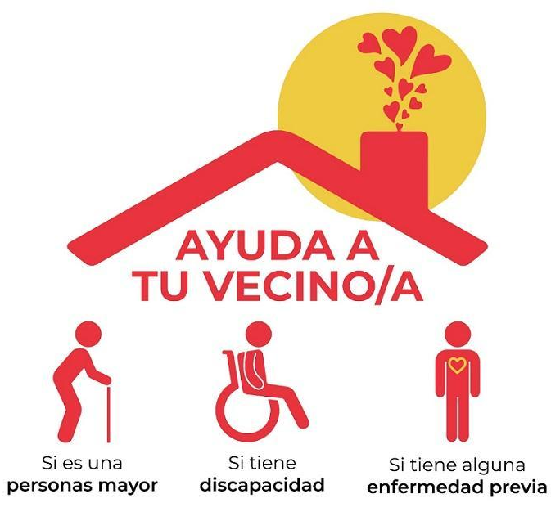
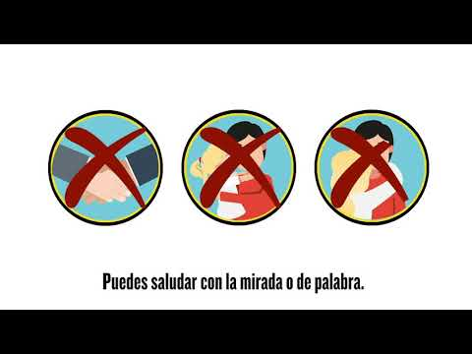

Section A
When watching the video, find the Spanish for the following:

- Keep / Maintain =
- Do not touch =
- Wash =
- Avoid =
- Do not greet =
- Do not give =
- Meet =
- Make sure =
- Clean =
- Do it =
- Open =
Section B
Now watch the video again. Write down a minimum of 5 recommendations from the Spanish government and translate them into English:
Example: Mantén una distancia de 1 ó 2 metros con otras personas. = Keep a distance of 1 or 2 metres from other people.

Section B
Now read the text below and answer the questions below.

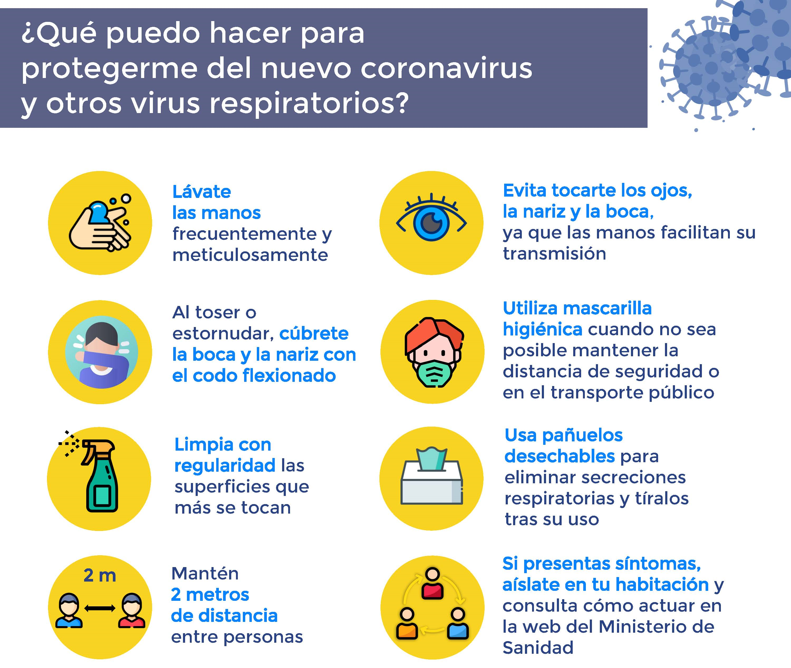
- How should you wash your hands?

- What should you do if you need to cough or sneeze?

- What sort of surfaces should you regularly clean?

- Why should you avoid touching your eyes, nose and mouth?

- When should you wear a mask?

- What should you do if you have symptoms?

Section C
In the video and the text, the “imperative” is used. The imperative is the grammatical term used for verbs when they give instructions. For example, in English when a teacher says “Listen” or “Stop what you are doing”, these are imperatives.
Watch the following video which explains how to form an imperative in Spanish. https://www.youtube.com/watch?v=ROd05uPWT4Y
Or click on the video below and it will play directly if you are connected to the internet.
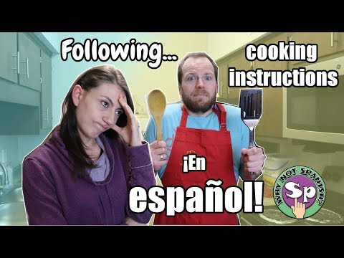
Write the following imperatives in Spanish:
- Turn on the stove. (prender = to run on)
- Add one teaspoon of garlic. (agregar = to add)
- Wait! (esperar = to wait)
- Cover the pot and lower the heat. (tapar = to cover / bajar = to lower)
- Eat and enjoy! (comer = to eat / disfrutar = to enjoy)

Try these new commands:
- Listen and write the date.
- Clean the board.
- Open the window.

Try these phrases which include irregular verbs. Check the video for the irregular verbs (minute 2:57):
- Say the truth. (decir = to say, tell)
- Be nice! (ser = to be)
- Do more! (hacer = to do)

Step Up to Spanish A Level

For a video explanation click here: https://www.loom.com/share/76a7e2da10114b87aad4d81a9354c3f1

How to learn Spanish?
When learning a language, the saying that “practice makes perfect” is very appropriate. You develop a higher level of comprehension (listening and reading) if you expose yourself to the language every day. The simplest of actions can help you develop vocabulary e.g. putting on Spanish subtitles on your favourite programme, changing the language settings on your email account to Spanish, etc.

This second set of activities focuses on the kind of things you can do regularly to develop these habits and to develop a great level of Spanish.

Transition Activities:
Preparing for A Level Spanish
You are to be set a further three tasks. These are linked to skills you will need at Spanish A Level. We will focus on:
- Sentence structure /grammatical accuracy
- Cultural awareness (- exposure to Spanish language music and culture)
- Vocabulary development + conceptual awareness (- the how and why of things)
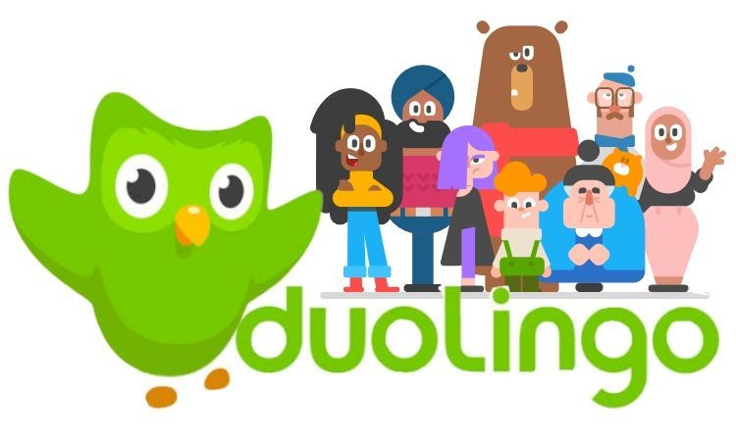
Task 1 – Sentence structure / Grammar
Complete a story on Duolingo every day
https://stories.duolingo.com/

Duolingo Stories is a way to practice your listening and reading comprehension using bite-sized interactive stories. By completing one every day you will get to revise and improve lots of language you have been learning so far in Spanish. Each task takes around 5-10 minutes.

You can complete Duolingo stories on the internet or on a mobile app.

When you first register (select the free account), you will take a quick test which will help the app to tailor the work set to your level.

Task 2 – Cultural awareness

As part of the speaking exam at A level, you will learn how to analyse texts and to infer meaning. Sometimes people imply meaning rather than saying things directly and when you understand the culture, this can further help to improve your comprehension.

We are going to look at a song by a band called Bomba Estéreo. Complete the following tasks:

- Go online and find out as much as you can about Bomba Estéreo e.g. Where are they from? How long have they been going? Have they ever performed in the UK?

- Watch the video for the song “Soy yo” (link on next page). Does the video help you to understand what the message of the song might be? If so, what do you think the message is? The message is implied.

Or click on the link - https://www.youtube.com/watch?v=bxWxXncl53U

Yo caí, me paré, caminé, me subí  Me fui contra la corriente y también me perdí  Fracasé, me encontré, lo viví y aprendí  Cuando más te pegas fuerte, más profundo es el beat  Sigo bailando y escribiendo mis letras  Sigo cantando con las puertas abiertas  Atravesando por todas estas tierras  Y no hay que viajar tanto pa' encontrar la respuesta  Y no te preocupes si no te aprueban  Cuando te critiquen, tú solo di  Soy yo  Soy yo  Soy yo  Soy, soy, soy, soy, soy, soy, soy  Soy yo  Yo, yo, yo, yo, yo, yo, yo  Sigo caminando y sigo riendo  Hago lo que quiero y muero en el intento  A nadie le importa lo que estoy haciendo  Lo único que importa es lo que está por dentro  A mí me gusta estar en la arena  Bañarme en el mar sin razón, sin problema  Estar sentada sin hacer nada  Mirando de lejos y estar relajada | Y no te preocupes si no te aprueban  Cuando te critiquen, tú solo di  Soy yo  Soy yo  Soy yo  Soy, soy, soy, soy, soy, soy, soy  Soy yo  Yo, yo, yo, yo, yo, yo, yo  Soy así, soy así, soy así  Relaja'a  Y tú ni me conoces a mí  Bien relaja'a  Soy así, soy así, soy así  Relaja'a  Y tú ni me conoces a mí  Bien relaja'a  You know what I mean  You know what I mean  Y no te preocupes si no te aprueban  Cuando te critiquen, tú solo di  Soy yo  Soy yo  Soy yo  Soy, soy, soy, soy, soy, soy, soy  Soy yo  Yo, yo, yo, yo, yo, yo, yo

- Have a look through the lyrics for the song + highlight any sentences that help explain what the song is about.

- Now read through an article (next page) that appears in an online newspaper from Colombia + answer a couple of questions.

“Soy Yo”, el video de Bomba Estéreo
Del álbum “Amanecer” nos llega la canción “Soy Yo” con un clip protagonizado por una joven heroína que no se deja intimidar por nada.
“No te preocupes si no te aprueban, cuando te critiquen tú solo di: ‘Soy yo’”, dice la canción. “El mensaje es el de no dejarse afectar por las críticas de otras personas y que la aceptación de uno mismo es esencial. El video se enfoca en los niños, haciendo referencia al acoso escolar que ocurre en los colegios”, añadió la cantante de Bomba Estéreo.

- Highlight parts of the text that support your view on what the song is about. Also, what is the singer from the band saying in her quote?

Task 3 – Vocabulary development + conceptual development

When covering all the General Topic Areas for A level Spanish you will encounter a wide range of vocabulary. Knowledge of a wide range of vocabulary is a key feature of high attainers at Spanish A level. This is a skill that you can develop independently by having regular contact with the language. An easy way of doing this is checking headline news and working out meanings. At the same time this helps you to develop greater awareness of issues and concepts and to develop your own views which is another important element of A level Spanish.

In Task 3 you will look at news and current affairs websites and work out what some of the articles are discussing. This will help you to develop your cultural awareness of what is happening in Spain and other Spanish-speaking communities.

It is generally best to start with international news as you will be more familiar with what is going on. Use the following two websites:

https://www.eldiario.es/

https://www.huffingtonpost.es/internacional/

Go to one of these websites and select a headline. To work out what the article is discussing you may want to use an online dictionary. Use the following: www.wordreference.com – this is used by professional translators and is one of the best.

Once you have selected your headline, pick out the key words, look up ones you do not know and produce a summary in English.
Example 1:
This is taken from the eldiario website:

The headline is talking about schools in France reopening (after the coronavirus lockdown), but this is for priority students depending on what type of work their parents do and their family situation.
Example 2:
This is taken from the huffingtonpost.es website:

The headline talks about Trump’s visit to a church that was set on fire during protests with a bible in hand.

- Do this at least once a week and keep a record of the new vocabulary.
- Learn the new words as you go along.

Support materials
The best online translator is www.wordreference.com

Another very useful website is www.linguee.com/spanish-english

Avoid Google Translate. This is not a very accurate tool and is best avoided unless it is for single words. Use WordReference and Linguee instead. The above websites also exist as free apps for your phone.
