"History is who we are and why we are the way we are”
David McCullough, Historian
History: A – Level Transition Guide
*For Year 11 pupils considering A Level History at Stepney All Saints
History teaches you valuable critical thinking skills, analysis, research, writing and communication skills to help you to solve problems and form arguments for debate
Students who study history are well prepared for both study at university and for employment in a wide variety of industries

History prepares you with analytical, writing, debate and detective skills, applicable for a range of careers including; law, politics, public sector, business, marketing, journalism, economics, teaching, academia, insurance, social research, archaeology and curation (museums, galleries, archives and libraries).

The course outline for A Level history at Stepney All Saints is as follows:

Year 12 | Breadth study with interpretations: 30%  In search of the American Dream: the USA, c1917-96 | Depth study: 20%  India, c1914-1948: the road to independence
Year 13 | Themes in breadth with aspects in depth: 30%  Britain: Losing and gaining an empire, 1763-1914 | Coursework: 20%  The origins and end of the Cold War

Core textbooks:
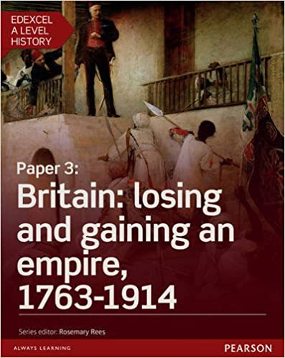
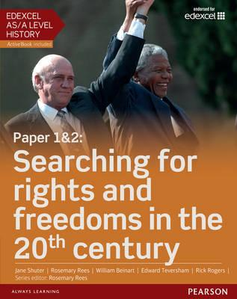

*further information about our exam board (Edexcel) can be found online at:
https://qualifications.pearson.com/en/qualifications/edexcel-a-levels/history-2015.html
Transition Activities: How can you prepare for A Level History?
Directions:
Work your way through each set tasks over the following pages. The tasks cover a range of skills and content that you will need to develop further in your study of A Level history.

Task 1:
Choose at least ONE of the following. Write a book review /article review/ film review, one page long. You can use the template provided on the following page and adapt as needed to aid you in this task.

Films/TV series:
BBC Empire - A Taste for Power (1 of 5) – available on Youtube
Indian Summer (Channel 4, 2015) BBC
Deutschland 83 (Channel 4, 2015) On Demand ALL4
The Post (2018) Available on Netflix
Hairspray (2007)

Novels:
White Tiger by Aravind Adiga
The Glass Palace by Amitav Ghosh
A Passage to India by E M Forster
Heart of Darkness by Conrad
To Kill a Mockingbird by Harper Lee
The Feminine Mystique by Betty Friedan
The Great Gatsby by F. Scott Fitzgerald

Articles:
Letter from a Birmingham Jail, Martin Luther King Jr.
https://warwick.ac.uk/fac/arts/english/currentstudents/undergraduate/20cusliterature/2016-17/martin_luther_king_letter_from_birmingham_jail.pdf

‘Why the Indian soldiers of WW1 were forgotten’, BBC, 2015,
https://www.bbc.co.uk/news/magazine-33317368

The war that launched the American Century, Telegraph 2014 [see appendix]

Book /Article/Film Review Task

Title:

Date published / released:

When was it set? What period does it cover?

Overview / synopsis (in your own words) of what happened and who was involved:

What historical information did you take away from reading/watching this work?

How accurate/reliable was the content portrayed? Explain why you think this.

Are there other ‘points of view’ or interpretations of the period covered in the work that you are aware of?

Would you recommend this to others? Why or why not?

Task 2:
Take a virtual tour of one of the following museums or historic sites.
[You can select any exhibit of your choice if you select a museum ‘visit’. Mr. Davis recommends the Smithsonian]

Directions: Write a one page summary of what you learnt from your ‘visit’.

Museums and historic sites of interest:
Smithsonian Institution, Washington DC | https://www.si.edu/exhibitions/online
British Museum,  London | https://britishmuseum.withgoogle.com/
Pergamon Museum,  Berlin | https://artsandculture.google.com/entity/pergamon/m05tcm?hl=en
The Louvre,  Paris | https://www.louvre.fr/en/visites-en-ligne
Versailles Palace,  Paris | https://artsandculture.google.com/project/versailles
Windsor Castle,  Windsor | https://www.royal.uk/virtual-tours-windsor-castle

*Local Visits: [if open and social distancing allows]
London Maritime Museum, Greenwich
Francis Drake’s Golden Hind, London Bridge
HMS Belfast, Tower Bridge
Science Museum (space race), Kensington

Museums / historic site of interest review:

Museum/site:
Exhibit:
What attracted you to this particular exhibit?

Why is this exhibit significant?

Task 3: Research task
Directions: Find an article online about a person or event in history that is important to you and write a one page review of this article.
Person/event:

Article title:

Date:

URL:

Questions to consider before you create your review:
Why is it important?
Who was impacted by this person or event?
Were there any long-term consequences?
Why is this relevant today?

Review task:

Task 4: Understanding arguments task
Directions: Read the two articles below about race and Civil Rights in 1980s America. Answer the questions that follow.

Understanding arguments tasks:
Extract 1:
What is the main argument?

What evidence / quote could be used to support the overall argument?

Extract 2:
What is the main argument?

What evidence / quote could be used to support the overall argument?

In a paragraph, explain the similarities and differences between the two extracts:

Task 5: Skills focus – eliminating irrelevance from answers
Below are a sample exam question and a paragraph written in the answer to the question. Read the paragraph and identify parts of it that are not directly related to the question. Draw a line through the information that is not relevant and justify your deletions below the paragraph.

Question:
How successful were mass protests in the USA in bringing an end to the Vietnam War?

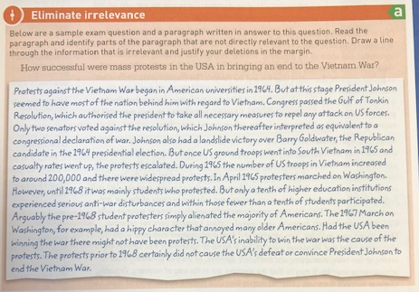

Justify why/what you eliminated from the sample response:

Task 6: Skills focus – identifying significance and prioritising examples
RAG – rate the timeline
Below are a sample exam question and a timeline. Read the question, study the timeline (and research on your own each of the events on the timeline to be familiar with them) and then using three coloured pens, put a red, amber or green start next to the events to show:

Red = events and policies that have no relevance to the question
Amber = events and policies that have some significance to the question
Green = events and policies that are directly relevant to the question

Question:
To what extent did Martin Luther King lead the civil rights movement in the years 1957-68?

Explain which event(s) was most important/significant in demonstrating the leadership of Martin Luther King in a PEEL paragraph.

APPENDIX
ARTICLE 1

The war that launched the American Century

When the US joined the First World War in defence of liberty it established itself as leader of the free world and shaped the Russian revolution
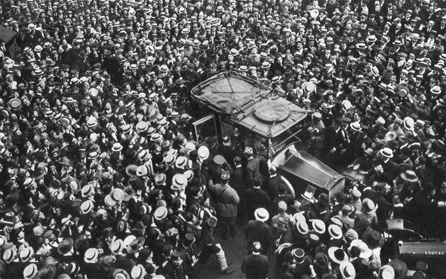
Crowds cheer US general John Pershing in Paris in 1917 as it is announced that America will join the conflict Photo: GETTY
4:05PM BST 03 May 2014
When Gen John Pershing arrived with the first American troops in Paris in the summer of 1917, he made a pilgrimage to a sacred site. It was the tomb of the Marquis de Lafayette, who despite his aristocratic lineage had gone to the aid of the American revolutionaries in their triumphant struggle against the British.
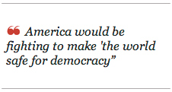
“Lafayette, nous voilà!” (Lafayette, we are here!) the general is supposed to have declared, though the words are more likely to have been uttered by his aide, Charles E Stanton. This act of homage was more than a mere courtesy. It was an expression — intended for international consumption — of the motivations that had propelled a largely reluctant United States into the war. By this gesture, America was saying that its decision to enter the conflict was driven by the same impulses that had moved Lafayette — that is, a hatred of autocracy and a desire to make the world a freer and better place.
This attitude represented a fundamental shift in America’s relationship with the rest of the world and had enormous consequences for the history of the 20th century. By raising its standard in the global defence of liberty, the US more or less guaranteed its participation in the next war. It would also pitch it into a long, ideological confrontation with the other power whose destiny was changed utterly by its involvement in the First World War – the Russian Empire in its incarnation as the Soviet Union.

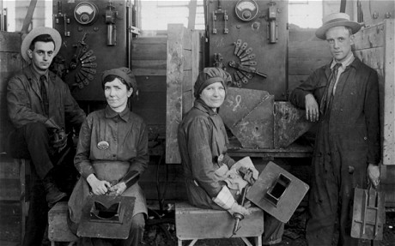
In 1914, the US intended to stay out of a conflict that seemed emblematic of the rottenness of old Europe, a place from which most Americans were thankful to have escaped. Step by inexorable step, the US was dragged in. The austere, high-minded president Woodrow Wilson won the 1916 election vowing to maintain neutrality. Germany’s actions, though, made the position untenable. In May 1915, a German U-boat sank the British liner Lusitania, killing 1,198, including 129 Americans. This and other
Two female welders in Philadelphia, the first US women to work in shipbuilding
sinkings piled further pressure on Wilson.
The revelation of the ‘‘Zimmermann Telegram’’ — a signal intercepted and deciphered by British intelligence from Germany’s foreign minister to his man in Mexico, offering the Mexicans the return of territories lost to the US if they joined the war on Germany’s side — helped generate support for war. On April 6, 1917, Congress voted to declare war on the Kaiser and his allies. Until then, America had done very well out of the war. Exports to Europe boomed and its financial institutions piled into markets previously dominated by Britain. Such a momentous step required momentous justifications and Wilson was the man to provide them.
US intervention would ensure this was “the war to end all wars”, said Wilson, and America would be fighting to make “the world safe for democracy”. Troops would not start arriving in large numbers until 1918, but their appearance was decisive.
If Wilson thought his vital contribution would mean he could dictate the terms of the peace, he was mistaken. His blueprint for a new world order was laid out in his ‘‘Fourteen Points’’ based on principles of open diplomatic dealing, free trade and national self-determination.
His proposed generosity towards the Germans was opposed with particular bitterness by the French, who demanded vast reparations for their losses and the military emasculation of their enemy. The Versailles Treaty thus ended up a mish-mash of Wilsonian idealism and old-fashioned vengefulness. It was a formula for trouble which the Wilson-inspired League of Nations created by the treaty could do nothing to avert.
The US was transformed internally by its entry into the war. The conflict was a struggle of competing resources and America’s were radically reorganised to maximise efficiency. Among the results were the penetration of women into blue-collar jobs that had formerly been exclusively male territory and the migration north of black workers to take the place of workers who had gone to war. This would lead, as soon as the war ended, to the 19th Amendment giving women the vote and, in the longer term, start the process of delivering racial equality.
Of all the combatant nations, the US did the best out of the war. It emerged from its brief but heavy involvement as unmistakably the most powerful nation in the world. Its tiny army had expanded to a mighty five million, laying the foundations for its military pre-eminence at the close of the century.
But this did not give Americans a taste for further adventures. In the 1920 election, Wilson tried to turn it into a referendum on the League of Nations. However, the Democrats were thrashed by the isolationist Republican candidate Warren Harding, America steered clear of the League and, for the time being, the US was plunged into contented neutrality.
But something had happened to the US that ensured this was to be the American Century. The experience of participation and victory gave the country a new cohesiveness and confidence that propelled it into the role of leader of the free world. Americans felt that they had set an example of how a nation - no matter where its citizens hailed from — should behave.
The feeling is evident in the patriotic musical fare served up by Tin Pan Alley, in particular the work of Irving Berlin. Berlin’s patriotism was heartfelt. His parents had fled the anti-Semitic pogroms of Tsarist Russia and, after an impoverished upbringing on New York’s Lower East Side, a string of hits had made him a Broadway star. Drafted into the army in 1917, he had done his bit for the war effort by co-writing such upbeat songs as Let’s All Be Americans Now.
The trauma of war was barely felt in America. Compared to the European belligerents, its losses of 116,000 dead were small. It was able to emerge from the conflict full of strength and optimism, convinced of the value of its institutions and way of life.
Russia’s experience of the war produced entirely the opposite effect. In the space of four years, the most autocratic government in Europe would collapse into revolutionary ferment from which would emerge the world’s first communist regime. The catastrophic defeat at the hands of the Germans at Tannenberg in August 1914 was a harbinger of the suffering to come. With the failure of successive offensives, casualty figures running into the millions and economic disaster leading to shortages of essential supplies, the incompetence of the Russian ruling class was laid bare.
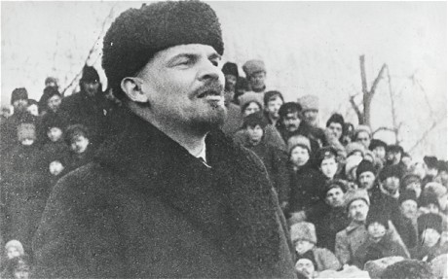
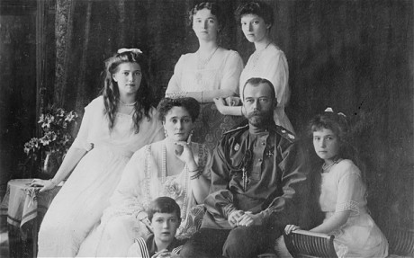
After Tsar Nicholas II appointed himself supreme commander of the army, the fortunes of the war and the house of Romanov became fatally intertwined. In the early months of 1917, hunger was added to seething discontent and, in Petrograd and other cities, bread riots erupted. Fearing revolution, the army’s high command forced Nicholas to abdicate. The swiftness of his departure amazed everyone. Even Lenin, watching with eager eyes from his exile in Switzerland, was taken aback. “It’s so staggering,” he told his wife. “It’s so completely unexpected.”
[Lenin addresses a rally in Moscow in 1917 / Tsar Nicholas II and family before the Russian Revolution]
When the Tsar’s brother, Michael, refused to replace him, three centuries of dynastic rule came to an end and the governance of Russia fell into the hands of an ill-assorted Provisional Government which struggled to maintain the war effort.
By now, the famously enduring troops had reached their limits. Soldiers’ committees sprang up demanding an end to the war. In July, another offensive was launched which, after initial successes, ground to a halt. The news triggered a further slump in morale and a surge of anger against the ruling class. Units refused orders to move to the front and millions deserted. In the countryside, armed bands turned on landowners, burning and killing.
Lenin was stuck in Zurich, stranded by the tides of war. At last, in April 1917, the German foreign ministry arranged for him and his entourage to be transported through their territory in a sealed train and then on to Sweden and home, in the hope that his return would accelerate the Russian collapse.
With Lenin’s arrival, events moved rapidly from upheaval to revolution. On reaching Petrograd’s Finland Station, he was met by a crowd of red flag-waving soldiers, sailors and workers who now controlled the city. He told them that “the worldwide socialist revolution has already dawned… We have to fight for a socialist revolution, to fight until the proletariat wins full victory!”
Lenin had abandoned existing Bolshevik policy to make it plain that there could be no accommodation with the moderate revolutionaries personified by Alexander Kerensky, the head of the Provisional Government. There was to be no parliamentary democracy, dominated by the bourgeoisie, but all power would rest with the soviets — councils elected by the workers. The lines were now drawn for a power struggle that would plunge Russia into an appalling five-year civil war.
After Kerensky ordered his arrest, Lenin fled to Finland. In October he returned to Petrograd, which was now controlled by the Bolsheviks. From there he plotted the coup d’état that would overthrow the Provisional Government and ultimately bring about communist rule. One of the Bolsheviks’ first acts was to announce Russia’s withdrawal from the war, which was formalised in March 1918 with the Treaty of Brest-Litovsk.
The Russian Revolution would probably have happened anyway. The traumatic effects of the war ensured that it arrived more quickly and in a more drastic form than might have been the case if it had evolved in peacetime. The triumph of American capitalism was also a historical inevitability, but accelerated by the industrial pressures of the war.
By its entry, America changed the course of the war. It did not, though, achieve its war aims. Wilson had talked about making the world “safe for democracy” and envisioned a post-conflict international landscape bathed in the light of reason and harmony. Instead, in Russia, autocracy was replaced by the dictatorship of the proletariat and everywhere in Europe saw the rise of fiercely nationalistic and anti-democratic parties.
As a result of the First World War, the world was presented with two completely contrasting models of how society might be ordered. One promoted materialism and personal liberty, the other collectivism and the virtue of the mass over the individual. The struggle between the competing ideologies would last for much of the rest of the century, being laid aside for a few years only when self-interest demanded that the US and the USSR joined forces against Nazism and Fascism.
Their shared victory only sharpened the rivalry, giving birth to a Cold War whose effects were felt all over the globe and linger today.

ARTICLE 2

