Step Up to A Level Drama and Theatre
I regard the theatre as the greatest of all art forms, the most immediate way in which a human being can share with another the sense of what it is to be a human being. Oscar Wilde

Welcome Theatre Lover

Congratulations you have made the very wise decision of choosing A Level Drama & Theatre studies.
Hooray! You will love it, but it is not for the faint hearted. You need to be dedicated,
work independently, meet deadlines, write up your notes of practical exploration after each lesson
and go to the Theatre lots.
Did I mention writing? ... well you will have to write.
A Theatre review, rehearsal process, play text research and interpretation of text.
It is a GREAT course but how much you put in, is how much you get out...... it’s up to you!
2022- 2024 Ms Hall & Ms Krisiloff

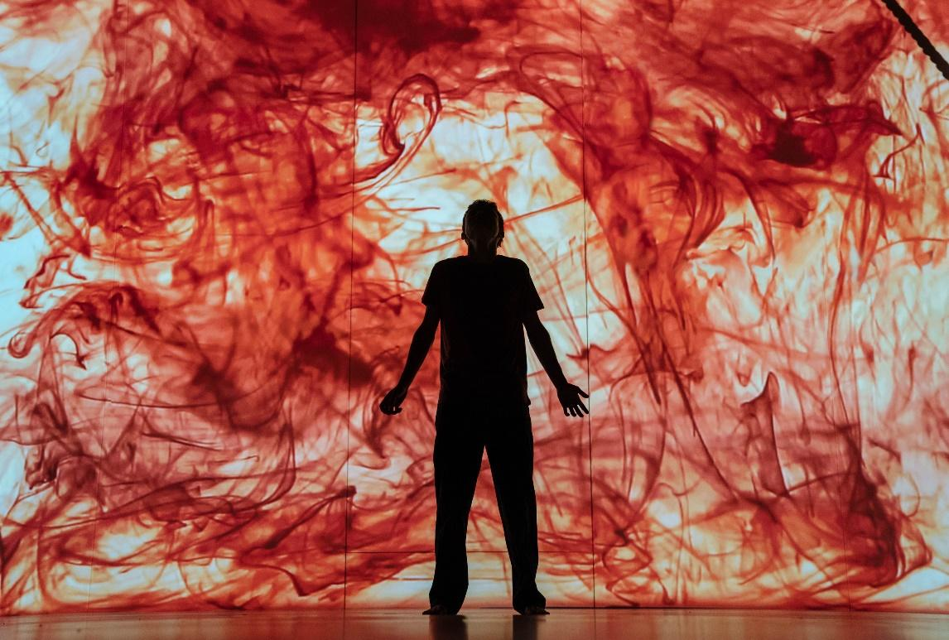

This Step Up to A Level Drama and Theatre Booklet is to help you build the skills you
need to be ready to start in September.
Top Universities such as Cambridge and Oxford love A Theatre Students.
AO1 Create and develop ideas to communicate meaning as part of
the theatre-making process, making connections between dramatic theory and practice 20 %
AO2 Apply theatrical skills to realise artistic intentions in live performance 30%
AO3 Demonstrate knowledge and understanding of how drama
and theatre is developed and performed 30 %
AO4 Analyse and evaluate their own work and the work of others 20%

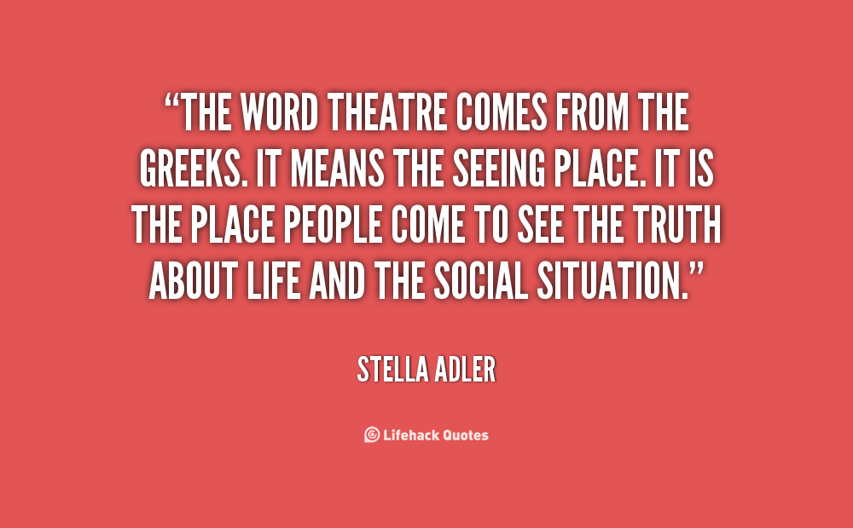

What is Theatre and drama?
Many theorists believe that human beings have the innate desire to inmate each other - mimesis.
It is in our nature to reflect on the world around us and try and make sense of it.
● Drama means conflict and action ‘to do’
● Theatre means the ‘Seeing place’
Task 1 WATCH https://www.youtube.com/watch?v=VeTeK9kvxyo
https://www.youtube.com/watch?v=sNWrOuwzax8

- What do you think the purpose of drama and theatre is?

Task 2:
Tell me why you think theatre is important in today’s society?

Task 3: Create a Drama and Theatre Mind Map. Put in any words or images that come to mind.
Do not hold back, write now or include images of anything that comes into your head.
Let your creative juices flow.

Task 4: Categorise these words in the order of importance when creating theatre and
give your reasons why.
Audience, Collaborate, Create, Intention, Practitioner, Themes/Issues and Ideas, Characters,
Performance, Rehearsal, Evaluate, Analyse, Refinement
Task 5: If I was to give you these images as a stimuli and ask you to create an original piece of
theatre using the stimuli below. Please write your ideas in response to mood board or a
mind map
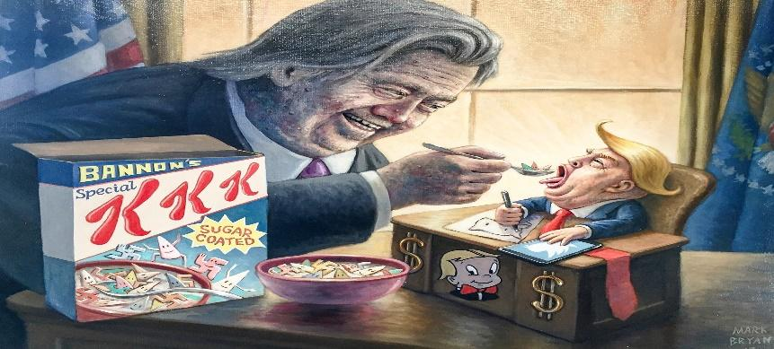

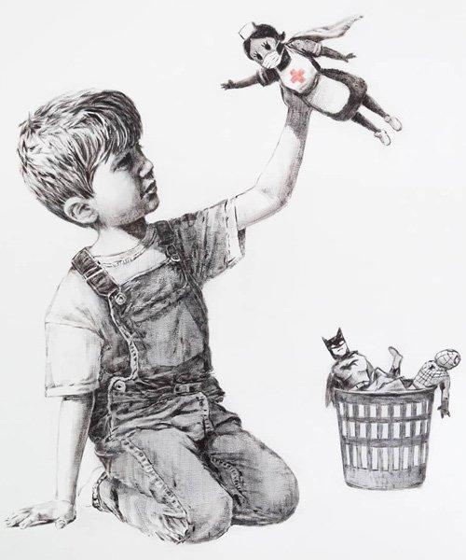

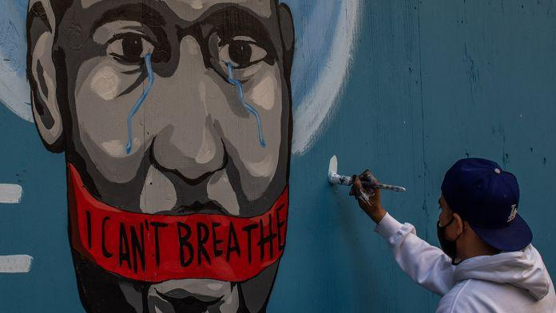

What ideas, words, or feelings does the stimuli provoke?

Task 6: Choosing 3 ideas from the above task– create three questions that you may answer dramatically.
For example - Are we being forced fed by political governments a diet of prejudice?

Task 7: Decide and write your intention of the original piece of theatre – ‘message to the audience’ Next choose a practitioner and give your reasons why that you will use to influence your vision for the play. Practitioner resource https://qualifications.pearson.com/content/dam/pdf/A%20Level/Drama%20an d%20Theatre%20Studies/2016/teaching-and-learning-materials/Practitioner- guide.pdf
Task 8: Watch this A Level Drama and Theatre studies original devised piece and write what you think their intention was and evaluate their success, at least 500 words. https://www.youtube.com/watch?v=dQ5RxI7X0Xw
What was their intention?

Evaluate how they achieved this?

Task 9: Read the script below aloud. ‘That Face’ by Polly Stenham’. Mia is 16 years old, privately educated in London. Her Mum and Dad are divorced. Hugh, her dad lives in Japan and Martha, Mia’s mother is co-dependent on alcohol and prescription drugs. Mia and Izzy victimised a younger student, Alice.

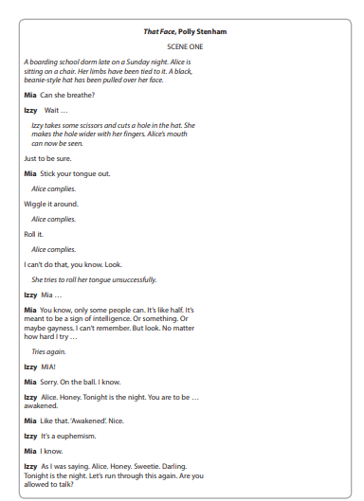

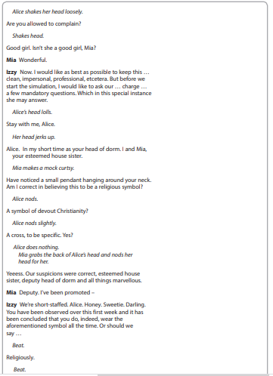

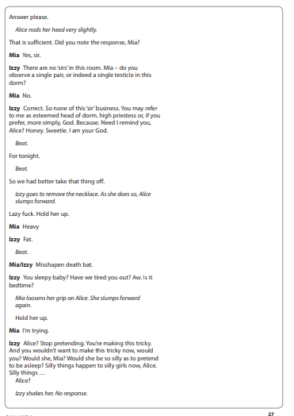

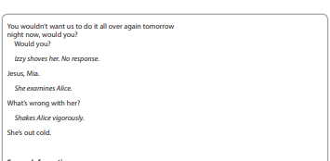

Task 9 continued:

As A performer you are going to play the role of Izzy, how would you used voice and gesture to create impact on the audience in this scene?

Task 10: Watch https://www.youtube.com/watch?v=jx9CuMObPK4 and read review.
Next colour code review
Blue - description of production elements or performance style
Red – analysis, meaning or interpretation
Green – evaluation effect on audience
Theatre Review. Performed at The Lyric Theatre Royal, Plymouth, Frantic Assembly’s production of ‘Othello’ delivers Shakespeare’s tragedy with a new relevance to modern society. The Lyric is a large, modern theatre, well suited to ‘Frantic Assembly’s unique style of performance in which there is a large focus placed on physical theatre and reflection on contemporary culture. The majority of the audience were young people here to see a present day take on a Shakespearian classic. One could be convinced that they were watching a completely modern play as, despite the use of Shakespearian verse, the content and messages present in ‘Othello’ were able to cut across a large time period in Frantic Assembly’s production, remaining thought provoking and captivating.

An energetic, modern take on Othello, the play was set in working class northern England – in contrast to the original backdrop of Venice and Turkey in the latter part of the sixteenth century. As the lights went up, the first backdrop to be seen was a shabby, dirty and worn down pub that consisted of a pool table, gambling machine and a door leading to the toilets.

I thought the decision to use a pub was successful as it put the story of ‘Othello’ into a modern day environment that many people are familiar with. The colours of the pub were very dingy and dark. Another setting used was a dark, car park covered in graffiti – a gloomy place where sinister brawls took place throughout. I found ‘Frantic Assembly’s’ use of dark backdrops effective as it directly paralleled the dark themes of Othello and provided insight to the devastating happenings that were about to take place. The set was also effective as it was relatively simplistic and did not detract from the play. This allowed powerful vocals and physical theatre to ‘speak for themselves’. A particularly clever use of set was the pool table. Throughout the play it was used in a variety of way and was often spun around. This created an interesting effect allowing people to boldly stand out on stage. When characters had something important or scandalous to say, they would often stand up on the pool table (this was common during soliloquies).

An interesting use of the medium of levels, this allowed importance to be highlighted and caused cast and audience members to take note of what was being said. It was mainly male members of the cast that stood up on the pool table. Iago and Othello both had extended dialogue on this platform. This demonstrated the male dominance that is rife throughout Othello in a symbolic way; the men were literally ‘above’ the women. Another notable part of the set was the concertina effect of the walls of the pub. This allowed movements to stand out and’ jump off’ of the stage, especially when used in conjunction with chorus work. In the drunken dance the company swayed, leaned and stumbled to show Cassio becoming increasingly inebriated. The use of spinning walls here was very powerful as it was metaphorical of the fact that when someone is drunk it is often said that the walls appear to be spinning.

Physical theatre was very effective here as the entire cast made bold, exaggerated movements in unison, making Cassio’s drunk demeanour more pronounced and clear. The characters in Othello were portrayed as working class young people making the production more appealing and relatable to the audience of young people.

The cast members were dressed in modern, relatively casual clothing. The use of costume in ‘Frantic Assembly’s’ production of ‘Othello’ was effective as characters dressed in accordance to their social status, this aided characterisation hugely and also general understanding of the play. For example, some cast members wore what many would commonly deem as ‘chavy’ clothing; for example, baggy tracksuit bottoms, belly tops and Nike trainers. This showed they were of a lower class when compared with other cast members. Othello, and his lieutenant Cassio, were of higher status than other characters. They wore more plush clothing throughout the production – Othello even wearing a bold, black leather jacket. Costume was also used for effect in chorus scenes. The ensemble of figures (all dressed in matching dark tracksuits) were in dark, violent gang scenes.

The convention of chorus used alongside physical theatre also featured here. Moving as a group, bold, harsh physical movements, such as stamping, added a sense of danger and threat to the scene. This was because it played on the fact that people have preconceived ideas that gangs and hoodie-wearing groups are to be feared, as well as using the dominating nature of a large group of people.

Sound was an extremely important factor and was used throughout the entirety of the production. Even before the play had begun, electronic style music could be heard. This slowly increased in volume and was effective in building a sense of tension and creating atmosphere. Music was played at different speeds and volumes in accordance with the happenings of different scenes. Forewarning of the violence and hurt that was to come, one of the earliest scenes was a fight in the pub. Fast paced, high volume music was suited very well here as this scene featured a dynamic physical theatre sequence (this included lots of punching and stamping to clearly show conflict). The sequence also involved the use of slamming down pool sticks. These bold movements were dramatically emphasized by loud, electro- style music and sound effects to show impact, such as loud crashes and bangs. This use of sound greatly increased tension and made the events of ‘Othello’ captivating and engaging for audience members.

Sound was considered down to the tiniest detail. During early dialogue scenes between Othello and other characters in the pub, a distant thump of disco music and occasionally barking dogs could be heard in the background to the current action. This made the events on stage seem all the more realistic and therefore more relevant. However, sound was not only used with the aim of being very loud and powerful. Sound had a completely different effect during more intimate scenes, showing the relationship between Othello and Desdemona. Soft, sensual music played and movement and conversation between the couple was very slow paced, greatly contributing to the desired effect of a romantic aura.

An example of this would be when Othello slowly, lovingly raised Desdemona above him whilst they lay on the pool table, used to make them stand out, whilst sleepy, soft music played. This created a very romantic tone and was also useful in showing the close relationship between Othello and Desdemona.In this same scene a warm rose spotlight focused solely upon them. This is an example of how lighting was used to create tone and effect throughout the production – in this scene it made these two main characters stand out and showed romance as colours like rose are often associated with love.
Lighting greatly differed throughout the production, changing in accordance with circumstance and overall mood. Natural lighting was used in pub scenes in order for it to appear realistic. However dark, gloomy lighting was employed in car park gang scenes to create a dark frightful atmosphere. Icy blue light, signifying cold cruel happenings, was focused solely upon Iago during his multiple soliloquys; the rest of the stage was left in darkness. I thought this was extremely effective use of lighting as it provided a metaphor that in ‘Othello’ the other characters are oblivious or ‘in the dark’ with regards to Iago’s sly plans.

In terms of the dialogue used throughout the play, I felt that the northern English vocals of the cast were quite unfitting to the Shakespearian verse. Although the desired effect was clearly to make what was being said more relatable and accessible, I felt that it was the contrary. Colloquial English was thrown in amongst Shakespearian verse, for example ‘That’ll be from drinkin’ babe!’. I felt that it was a true mismatch and, although seeming a promising and interesting concept, the original dialogue of ‘Othello’ was not done justice and was detracted from. However on a different note, what was interesting about ‘ Frantic Assembly’s ‘ production was that , even if Shakespeare’s words were taken away what would still be left is a very topical play about respect , racism and gang culture that is still relevant to our lives today and is full of realism.

A highlight of the production for me was Charles Aitkens performance as Iago. I felt he was exceptional at playing this vindictive bully, exploiting the jealous feelings of others and reaping devastation whilst concealing his own vulnerability and envy. Charles Aitken’s Machiavellian smile added an interesting, comedic and slightly sinister aspect to the character. An absolute master of manipulation, Iago showed that, whether Shakespearian or modern times, the people we trust the most are commonly the ones that hurt and betray us. Aitken portrayed this extremely well in his performance through his deceitful demeanour. His stage positioning was very effective as where he stood meant that he was able to make gestures and facial expressions that only audience members could see. This meant that the other characters were oblivious to his sly, scheming nature.

Frantic Assembly used repetition throughout the production in order to show the change in tone and relationships between characters as the play progresses. For example, when Othello –blinded by jealousy – murders Desdemona. This tragedy is portrayed when Othello brutally strangles his wife, as he raises her above him whilst lying on the pool table. This action is identical to Othello lifting Desdemona above him in their previous romantic, pool table scene. However, completely different emotions are portrayed as actor, Mark Ebulue, performs the physical movement in a harsh, sharp and powerful manner as opposed to being gentle and soft. This is a strong use of contrast and proved extremely effective in showing how the emotions of Othello have been utterly transformed; love and care has been replaced by jealousy and hatred. This use of contrast was also furthermore employed in lighting and sound choices. In complete conflict to warm, amber lighting and sensual sound, aggressive music of very high volume shook the theatre. This clearly showed the climatic nature of this scene and captivated and shocked the audience.

Mark Ebulue used loud booming vocals to project the line ‘I kissed thee ere, I killed thee’.This mirrored how serious and shocking the act he had committed was. Othello is left standing, completely alone, in the middle of the stage. This was effective as it was metaphorical of his emotions and provided character insight; Othello is corrupted by guilt and loneliness at this point in the play. Mark Ebulue showed the extent of Othello’s frank, deep remorse through his use of exaggerated facial expressions and frantic pacing which clearly indicated trauma and distress. In the final moments of the play, powerful, electric music – of an even greater volume than ever before in the production – is played.

The music reaches a crescendo and bright flashing lights dart around the stage. This was used to increase tension and create suspense surrounding what is to come. Plagued by overwhelming remorse and regret, Othello then pulls out a knife and stabs himself. A blackout follows this immediately and the entire theatre is left in darkness. This was another extremely effective use of contrast and left audience members in complete shock at the awful happenings. The quick drop from a climax of intense light and sound to none at all was a useful way of capturing the tremendous loss of life and the dark mourning emotions and emptiness which are associated with death.

In this production the purpose of giving Othello a new relevance is met; the production is energetic and engages the audience from the beginning to end. Frantic Assembly’s modern interpretation did indeed provide a rollercoaster of emotions and convey the message that, although centuries may pass, the struggles people face (being manipulated, trusting the wrong person) do remain the same

Task 10: Watch and review either Theatre production online Macbeth or It Is Easy To Be Dead
Macbeth https://www.youtube.com/watch?v=PFwHmgA9nno
It Is Easy To Be Dead https://www.youtube.com/watch?v=pp4UViAliLM&t=5s
In a nutshell:
C1 Devising
One devised performance from stimuli (the same as GCSE Drama) under the influence of a practitioner
● Create and perform and original piece of theatre
● Write a Devising Portfolio describing, analysing and evaluating the process

C2 Text in Performance
- A monologue or a duologue and a group performance of a published play.

C3 Theatre Makers in Practice
● Section A - Theatre Review
● Section B- That Face (Set Text)
● Section C- Woyzeck (Set text)

How else can I prepare? Get ahead with the reading texts!
- WOYZECK George Buchner – Downloadable from the Edexcel website
https://qualifications.pearson.com/content/dam/pdf/A%20Level/Drama%2 0and%20Theatre%20Studies/2016/teaching-and-learning-materials/gce- woyzeck.pdf

- THAT FACE
https://www.amazon.co.uk/That-Face-Polly-Stenham/dp/0571244211
See as much live theatre as possible!
- Sign up to mousetrap C145 to get £5 tickets to West End Shows!
- Sign up to the National Theatre Entry Pass to get £5 tickets!
- Sign up to young Barbican for £5 theatre tickets
- Sign up to RSC Key to get £5 Shakespeare shows – you can also opt to stand at the Globe for just £5
- Open air theatre BREEZE – gives you £10 tickets
- Young Vic give you £10 tickets if you are under 26!
- Donmar Warehouse Young Free – FREE TICKETS TO THEATRE SHOWS – NO CATCH! Sign up to them.
- Hampstead downstairs club £5 tickets – sign up
- Almeida Theatre does £5 tickets for those under 25, use the UNDER25 code
- Tricycle Theatre £10 tickets
The London Theatre scene is huge-Westend to Fringe Theatre. Seeing theatre helps you create stunning work and help you understand the meaning and purpose of theatre. We will go to the theatre together many, many times!

Advice from previous A LEVEL DRAMA AND THEATRE students:
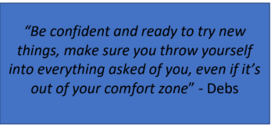

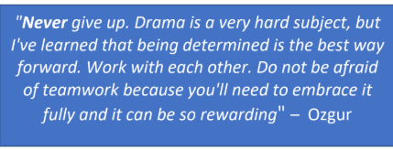

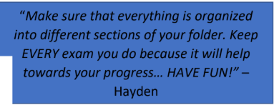

Now that you have completed the booklet
Be ready for your first lesson. You will share your knowledge.
Below is a list of Practitioners, you will need to know who these people/companies are and how they influence your work. E.g.
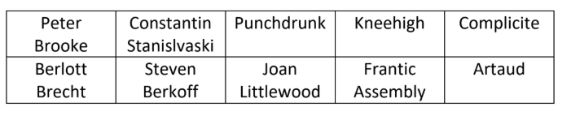
Brecht likes to use Placards in his work so you might use them in your presentation

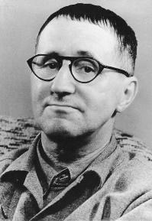
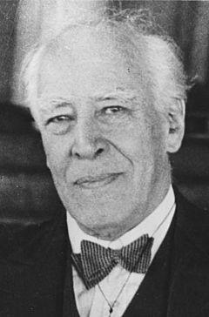
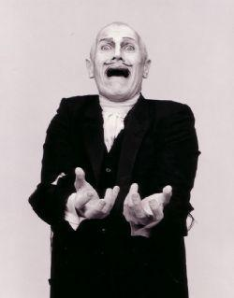
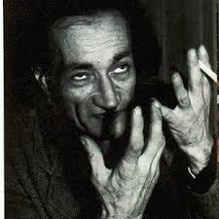

Pick one practitioner from above list you must prepare the following presentation to
shared based on the questions below:
1. What is a theatre practitioner?
2. What is the difference between style/genre?
3. What style does this practitioner use?
4. Create a presentation on this Practitioner
5. Include 3 practical activities which demonstrate the style of the practitioner
and will lead in a workshop

This is due the FIRST LESSON BACK in September 2020.
Any questions please contact Ms Hall or Ms Krisiloff over the summer.
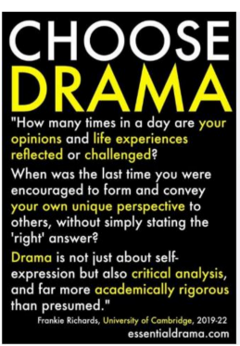
We have lots of resources to help you
lhall88.211@lgflmail.org
skrisiloff2.211@lgflmail.org
FINAL WORDS Please Watch and Read
https://www.youtube.com/watch?v=q3DGHtpuV28&feature=youtu.be&fbclid=IwAR0AOCqkwT TLTX8FQBJ_tonEJvshXroOlH-r4BdWMy4GJ8SvSWAmHqvq uG8

